Date:
CO-2:

Experiment No. 4
Title: Green Synthesis of Biodiesel from Vegetable Oil Using Base Catalysis

Aim: To synthesize biodiesel (fatty acid methyl esters) from vegetable oil using methanol and sodium hydroxide as a catalyst, following green chemistry principles.

Chemicals Required:
Vegetable oil 50 mL Food-grade (e.g., sunflower oil)
Methanol (CH₃OH) 12 mL
Sodium hydroxide (NaOH) 0.5g
Distilled water As needed For washing the biodiesel

Apparatus Required:
• 250 mL conical flask
• Measuring cylinders
• Waterbath
• Separating funnel
• Beaker
• Funnel, filter paper, butter paper
• Spatula, etc.

Theory:
Biodiesel is produced via trans-esterification of triglycerides (in vegetable oils) with an alcohol in the presence of a base catalyst. The chemical reaction is:
Vegetable Oil + Methanol → Biodiesel (Methyl esters) + Glycerol
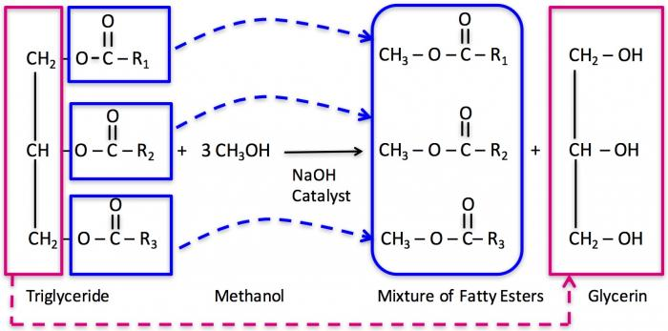

This experiment demonstrates several principles of Green Chemistry, such as:
• Use of renewable feedstocks
• Design of less hazardous chemical syntheses
• Energy efficiency
• Safer solvents

Procedure:
Step 1: Preparation of Catalyst Solution
1. Weigh 0.5g of NaOH and dissolve it in 12 mL of methanol in a 250 ml conical flask.
2. Stir the solution until NaOH is completely dissolved.
Step 2: Transesterification Reaction
3. Add 50 mL of vegetable oil to the same flask.
4. Heat the mixture to ~55- 60 °C while stirring continuously for 45 minutes in waterbath.
Ensure the temperature does not exceed 65 °C (methanol boiling point).
Step 3: Separation
5. Pour the reaction mixture into a separating funnel.
6. Allow it to stand undisturbed.
7. Two distinct layers will form:
- Upper layer: Biodiesel
- Lower layer: Glycerol
Step 4: Washing the Biodiesel
8. Drain the lower layer in a conical flask.
9. To the layer in the separating funnel add warm distilled water (15– 20 mL) and swirl gently to remove impurities.
10. Allow the layers to separate again; remove the water layer.
Step 5: Drying
12. In a separate conical flask, take small quantity of anhydrous calcium chloride. Take the biodiesel layer in it. Shake properly and let it stand for sometime.
13. Filter the supernatant through filter paper.
14. Collect the filterate and measure the biodiesel volume using measuring cylinder.

Precautions:
1. Handle methanol and NaOH with care.
2. Conduct the reaction in a fume hood.
3. Do not overheat the reaction mixture (methanol is volatile and flammable).
4. Allow complete separation of layers before collecting biodiesel.
5. Dispose of glycerol and wash water as per lab waste disposal guidelines.

Observations:
Appearance of vegetable oil: _____________
Catalyst used- Sodium hydroxide; Solvent/ Alcohol used Methanol
Reaction temperature __________ ; Time taken for reaction _________ mins
Time taken for layer separation _______ mins
Appearance of biodiesel- ____________________
Glycerol layer- ________________
Number of washes required ________
Volume of oil obtained = ______ ml

Results:
• Biodiesel was successfully synthesized using vegetable oil and methanol under basic conditions.
Volume of Biodiesel = __________________ mL

Assignment:
- What is biodiesel and how is it produced?

Biodiesel is defined as a diesel fuel substitute derived from renewable resources, specifically a family of products known as alkyl esters of fatty acids, created from vegetable oils or animal fats in combination with alcohol. It is commonly produced through a process called transesterification and can be sourced from materials such as rapeseed oil, soybean oil, recycled cooking oils, and microalgae.

- What role does NaOH play in this reaction?

In this reaction, NaOH plays the role of a catalyst.

- Why is methanol used in excess?

Methanol is used in excess due to the nature of equilibrium and reversibility of the biodiesel production reaction. the excess methanol is employed to favor a more complete reaction to achieve a higher quality product.

- How does this experiment follow green chemistry principles?

Usage of renewable feedstocks like vegetable oils or animal fats instead of fossil fuels to create energy is sustainable for the environment. The usage of NaOH catalyst follows the principle of using catalytic reagents rather than stoichiometric reagents. Biodiesel is considered a green fuel because it can significantly reduce greenhouse gas emissions compared to traditional fossil fuels. It also can break down naturally in the environment over time since it is a biodegradable fuel, unlike petroleum based fuels that persist in the environment for longer periods. Thus, synthesis of biodiesel and consequently this experiment follows green chemistry principles.

- What are the by-products of the reaction?
The product generates by-products of crude glycerol, soap, excess alcohol, and small amounts of water.

- Can ethanol be used instead of methanol? Why or why not?

Yes, ethanol can be used for the reaction instead of methanol. It can be preferred due to its lower cost and using alcohols of higher molecular mass can improve the cold flow properties of the resulting ester, at the cost of lesser conversions into biodiesel than can be achieved using methanol.

